
Fill Your Speaking Calendar NOW
The Easiest Way to Book More Gigs and Attract New Clients

Course Outline

- The Big Picture Strategies
- Define Your Ideal Audience
- Tactics to Find and Book Gigs
- Q & A
- Tactics to Find and Book Gigs (continued)
- Next Steps to Turn Unpaid Speaking into High-Quality Paying Clients
- Q & A

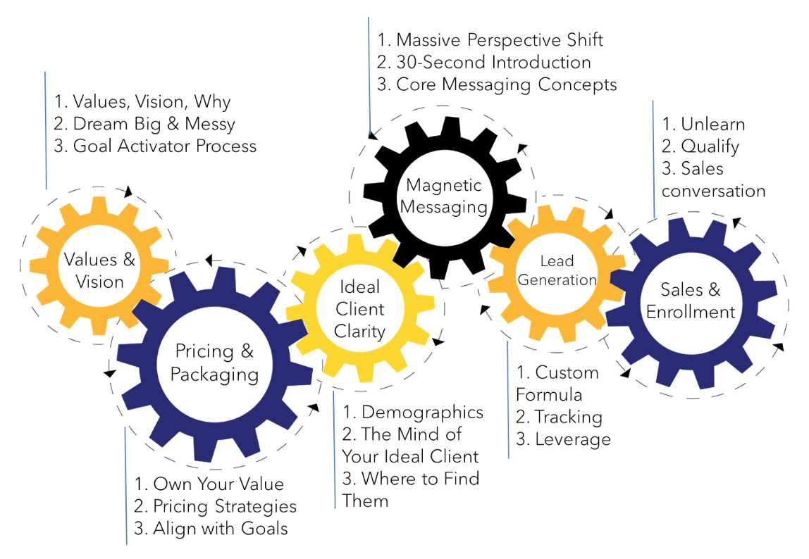

1. The Big Picture Strategies
The 3 keys to attract high-quality, paying clients through unpaid speaking.
1.
2.
3.

2. Define Your Ideal Audience.
Where your focus must be:
Everything about your _______________ - the audiences you get in front of, your title, the content, the offer – all must be designed exclusively with your ____________ _______________ in mind!

Why define your audience?

Ideal audience, defined:
Your ideal audience is where your ideal clients show up in __________ ________________________.

Speaking Gig Search Organizer

1. | 2. | 3.

- Who IS your ideal client? The basics…

- Industry
- Age
- Gender
- Specific life event
- Corporate
- Business Owners
- Leaders
- Experience Level

- Where do your ideal clients gather?

- Chamber of Commerce
- Professional Group
- Industry Association
- Conference
- Convention
- Retreat
- “Monthly speaker”
- “Breakout session”

3. Tactics to Find and Book Gigs
BOOKING TACTIC 1: Online Search
Method
__________________________ + __________________________ +
__________________________ (optional)
Other helpful searches:
- Events for DESCRIPTOR in LOCATION
- Conference for DESCRIPTOR in LOCATION
- Groups for DESCRIPTOR in LOCATION
- Where do DESCRIPTOR gather?
- Associations for DESCRIPTOR in LOCATION
A Word About AI...

Time and logistics of searching

To stay organized with your searches, consider trying this program: https://simplygetclients.com/Monday. When you enroll with this link, my team (at no cost) will set up the exact tracking system we use right in your account.

The NEW Magic Email

Subject: How do I apply for your [group name] group?
Hi NAME,
What is the process for becoming a presenter for your group? I’d love to be considered!
Thanks in advance for your help.
Mary

Two instances when the Magic Email doesn’t work.

BOOKING TACTIC 2: Referrals
Script:
“What groups do you attend that have guest speakers?
I speak on the topic of _____________. Would you be willing to introduce me?”

BOOKING TACTIC 3: “Follow” Method

BOOKING BOOSTERS

“I’d like you to think of another group you attend. [pause] If you enjoyed this today, I would appreciate an introduction to other groups who look for speakers on this topic.”

“Are there any other groups you know who look for speakers like me?”

If they answer: “Hi, I’m calling because I have a question about your [NAME] Group. I was wanted to know the process for being considered as a speaker – are you the right person to talk to about this?”
Message: “Hi this is Mary Cravets, I’m calling because I have a question about your [NAME] Group. I just had a question about your programming… could you give me a call back? Or if it’s easier you can email me at mary@simplygetclients.com.”

4. Next Steps to Turn Unpaid Speaking into High-Quality Paying Clients
The Mistakes Speakers Make

Resources and Next Steps to Consistently Attract New Clients Through Speaking
1.

2.

3.

1. Book Speaking Gigs
Checklist
- Title
- Define audience
- Online searching
- Referrals
- “Follow” method
- Magic email
- Talk description write up
- Boosters
- From the stage
- Ask the organizers
- Use the phone

Success Factors
- Knowledge of ideal client
- Clarity of messaging
- Time management
- Commitment to taking action
- Consistent implementation
- Consistent outreach
- Consistent action

2. Content that Creates Curiosity and Desire
Checklist
- Opening laugh/yes to immediately get people engaged
- What the audience will learn
- Your story
- Signature System that reveals there’s more to learn
- 3 teaching points with engagement and an “aha” moment
- Case studies to deepen learning and build credibility
- Seeding to create curiosity and desire
- Interaction to keep people engaged
- Gather contact information
- Drawing give-away or freebie
- Questions that reveal the gap
- Ask for referrals for speaking gigs (after offer)

Success Factors
- Knowledge of ideal client
- Clarity of messaging
- Self-discipline to create the structure, even if it feels counter-intuitive
- Trust in the structure, even though it’s unfamiliar
- Trust yourself!

3. Confidently Make an Irresistible Offer
Checklist
- Set up appointment booking system
- Set up easy URL
- Decide on offer:
  - Paid or unpaid?
  - Individual or corporate?
- Offer Script: Transition from content
- Offer Script: Who is this offer for?
- Offer Script: If you offer a complimentary call, what can they expect on the call?
- Offer Script: Logistically clear invitation.
- Offer Script: Immediate action incentive.

Success Factors
- Practice 10x more than content
- Sales process – so these leads convert into clients
- Be disciplined with your time so you don’t sabotage yourself (I have a timing outline I follow EVERY time!)
- Follow your offer script!!!
- Make the people you could serve more important than your fears.
- Trust yourself!
- Get the idea of a “pitch” out of your head

